**10 pyramidal neurons – ATP metabolism rate full**

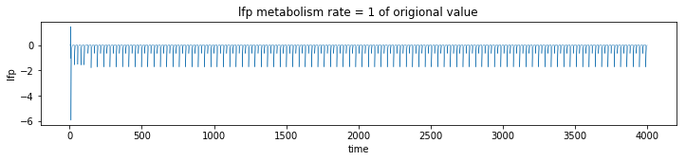

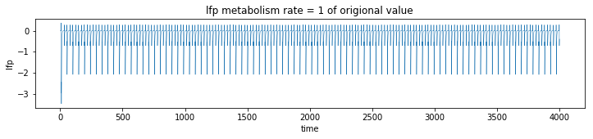

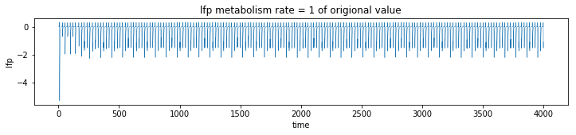

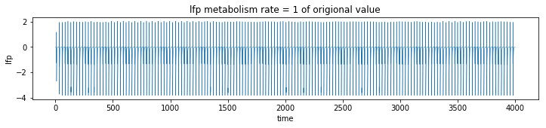

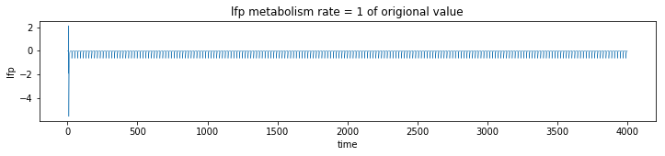

**10 pyramidal neurons ATP metabolism .5**

